Module 5 - Revenue Strategy Dashboard
This dashboard consolidates revenue performance across services, room categories, and seasons, helping managers understand total revenue contribution and identify growth levers.
1. Upsell Potential – Ancillary Services
Dining, Spa, Transportation, Recreation and Laundry revenues are visualized to highlight non-room spend opportunities.
It helps identify which departments can be promoted through:
- bundled offers
- cross-selling
- seasonal packages
- premium upgrades
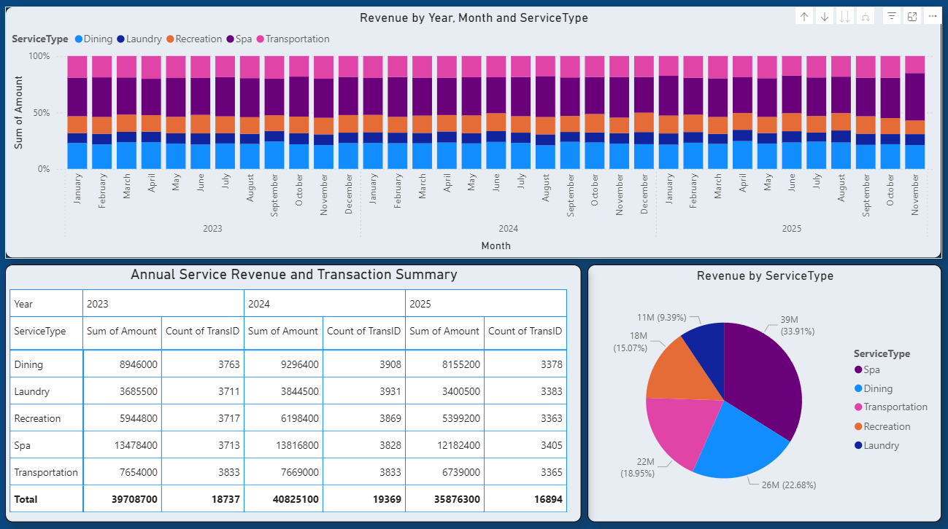
2. Pricing Tiers – Seasonal + Room Type
Room categories are mapped with High, Low and Shoulder seasons, enabling data-based pricing tiers:
- High season → premium rate
- Low season → discount strategy
- Shoulder season → competitive pricing
This helps optimise ADR and RevPAR by season and room class.
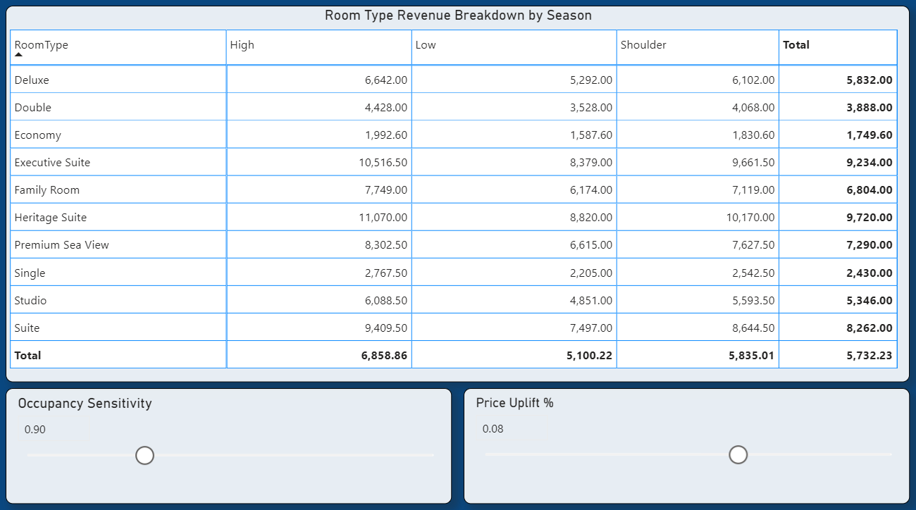
3. Interactive Parameters
Two dynamic controls:
- Price Uplift %
- Occupancy Sensitivity
Managers can simulate how a price increase or occupancy change impacts projected revenue. 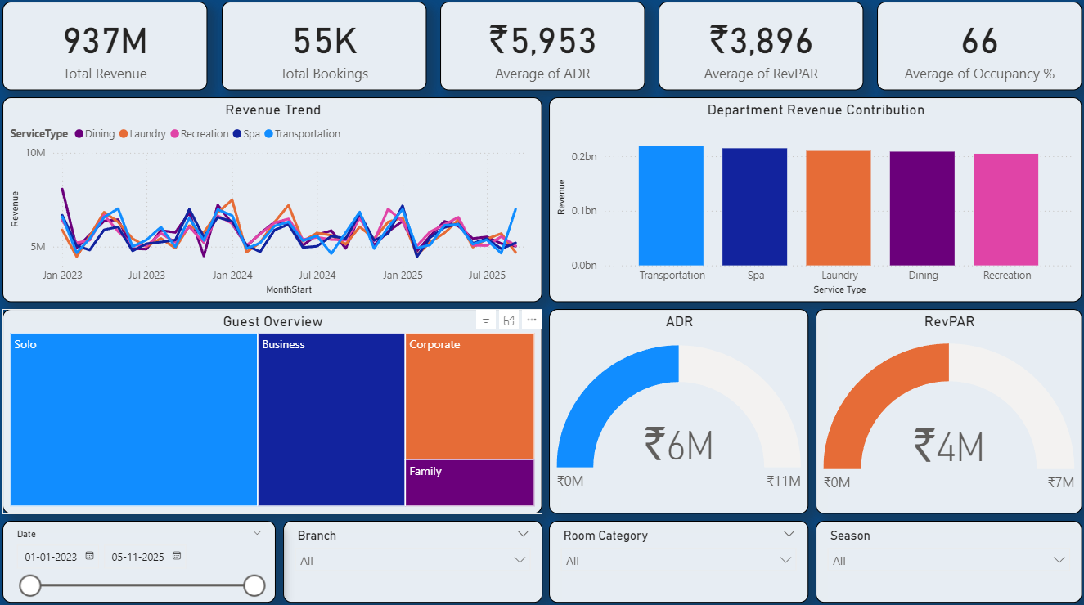

4. Scenario Demo – Baseline vs Adjusted KPIs
Users can quickly compare current KPIs with adjusted KPIs after changing sliders, giving a real-time forecasting view of:
- ADR
- RevPAR
- Occupancy
- Total revenue impact
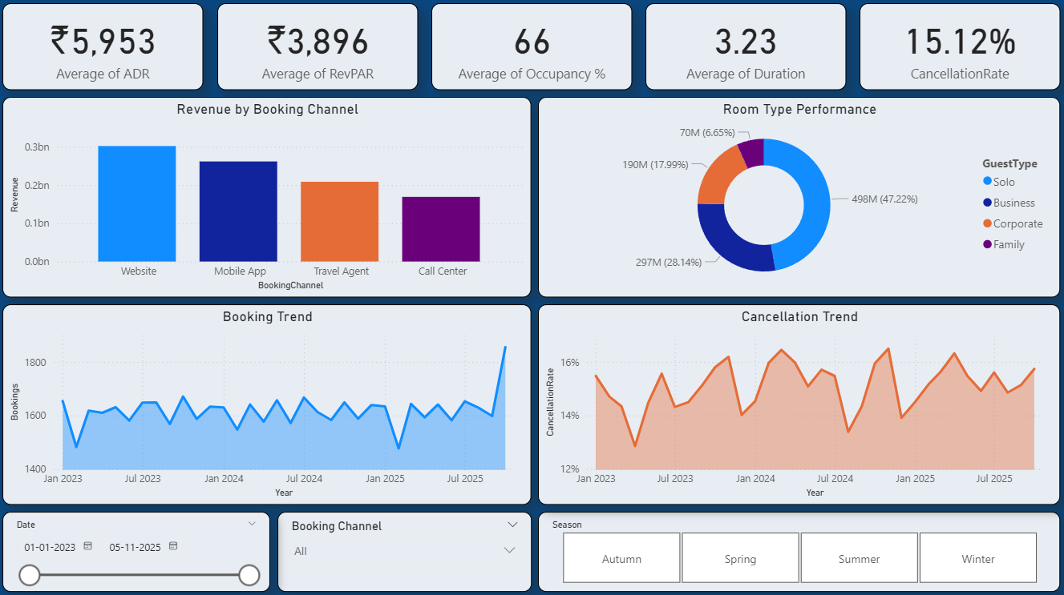
5. Impact – Actionable Insights for Managers
This dashboard enables managers to:
✔ set price strategies
✔ push ancillary sales
✔ evaluate scenarios
✔ optimise seasonal pricing
✔ maximise revenue per guest
Overall, it supports data-driven revenue decisions and proactive strategy planning.

